DATA SCREENSHOT NETBEANS PENJUALAN HIJAB BIMEFANDAH

TABEL DATABASE

Tabel Barang

|  |  |  |  |
| --- | --- | --- | --- |
| Field | Type | Size | Keterangan |
| Kd_brg | char | 5 | Primary key |
| Nm_brg | Char | 20 |  |
| Harga | Int |  |  |
| Stok | Int |  |  |

Tabel Supplier

|  |  |  |  |
| --- | --- | --- | --- |
| Field | Type | Size | Keterangan |
| Kd_supp | char | 5 | Primary key |
| Nm_supp | Char | 20 |  |
| Alamat | char | 40 |  |
| telpon | Char | 15 |  |

Tabel Pemesanan

|  |  |  |  |
| --- | --- | --- | --- |
| Field | Type | Size | Keterangan |
| no_pesan | char | 5 | Primary key |
| Tgl_pesan | Date |  |  |
| Total | Int | 8 |  |
| Kd_supp | varchar | 5 |  |

Tabel detail_pesan

|  |  |  |  |
| --- | --- | --- | --- |
| Field | Type | Size | Keterangan |
| No_pesan | Char | 5 | Foreign key |
| Kd_brg | Char | 8 | Foreign key |
| Qty_pesan | Int | 11 |  |
| Subtotal | Int | 11 |  |

Tabel Penjualan

|  |  |  |  |
| --- | --- | --- | --- |
| Field | Type | Size | Keterangan |
| No_penj | Char | 5 | Primary key |
| Tgl_penj | Date |  |  |
| No_faktur | Char | 10 |  |
| Total_penj | Int | 11 |  |
| No_pesan | Char | 8 | Foreign key |

Tabel detail_penjualan

|  |  |  |  |
| --- | --- | --- | --- |
| Field | Type | Size | Keterangan |
| No_penj | char | 8 | Foreign key |
| Kd_brg | Char | 5 | Foreign key |
| Qty_penj | Int | 11 |  |
| Sub_penj | Int | 11 |  |

CODING

BARANG.JAVA

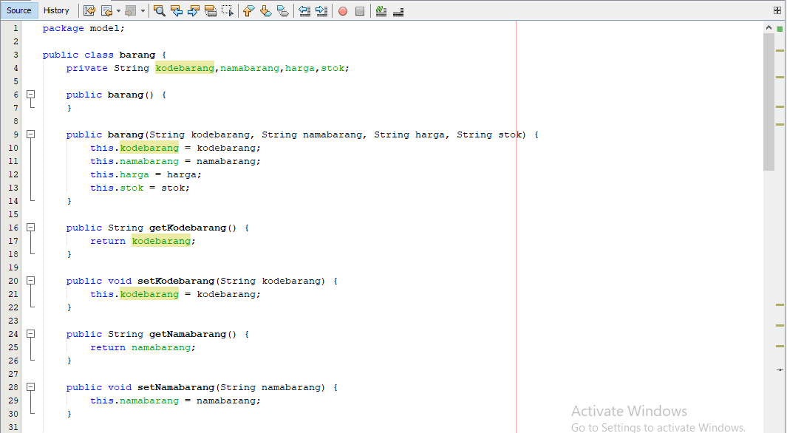

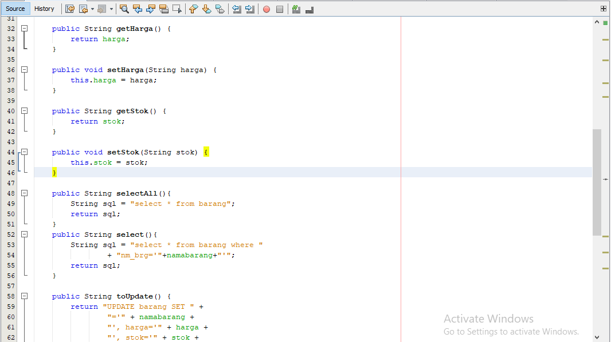

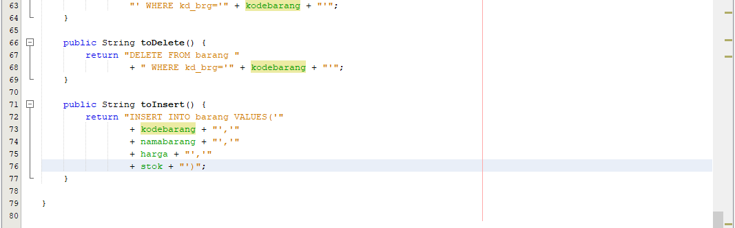

SUPPLIER.JAVA

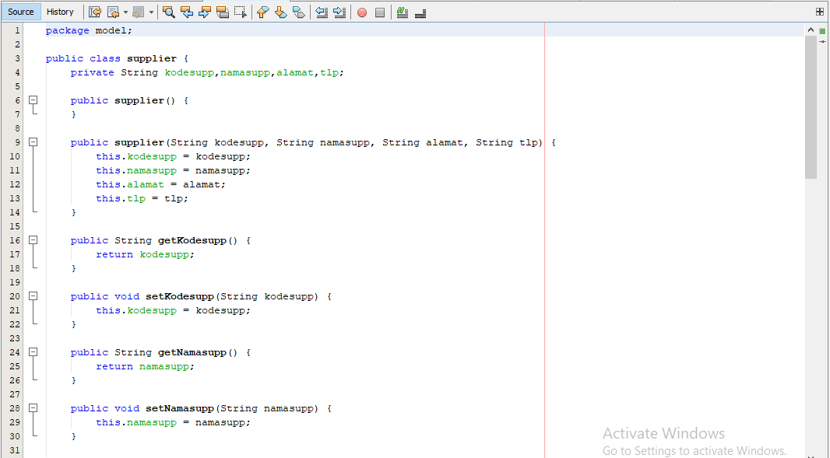

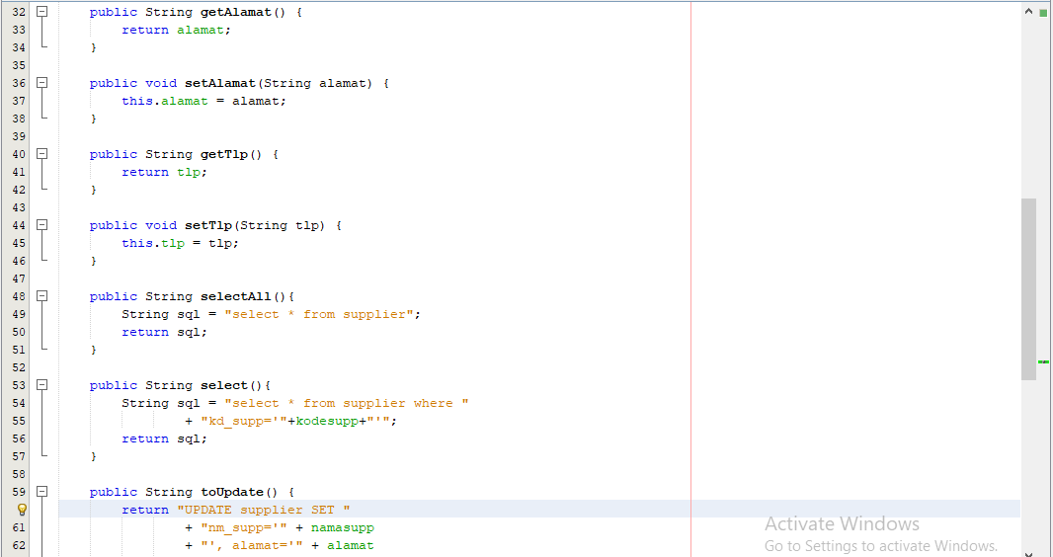

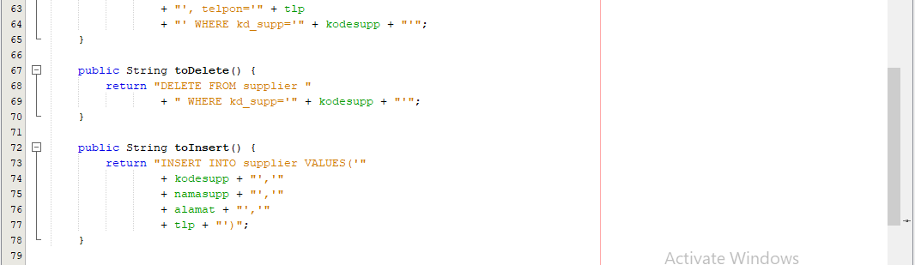

PEMESANAN.JAVA

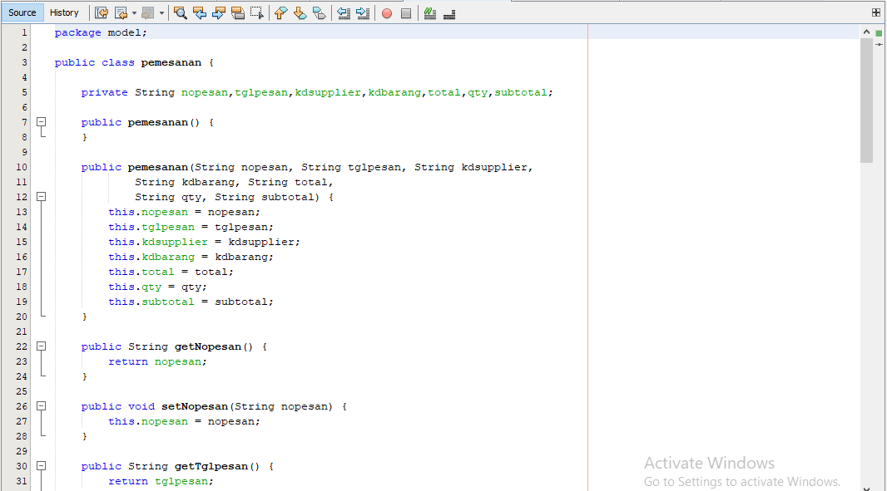

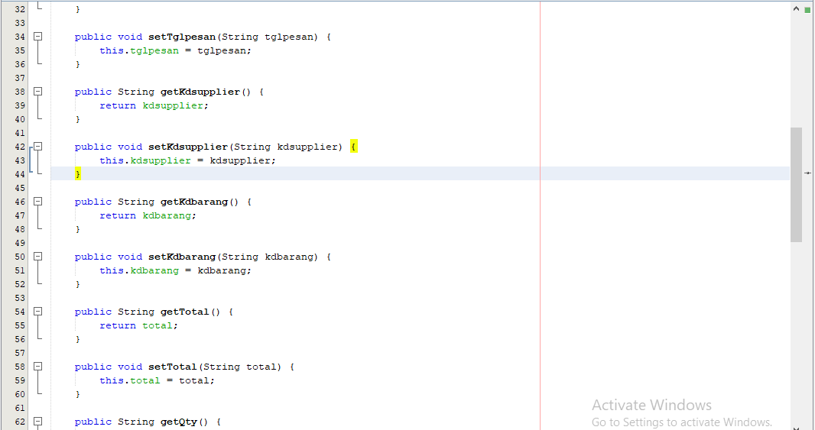

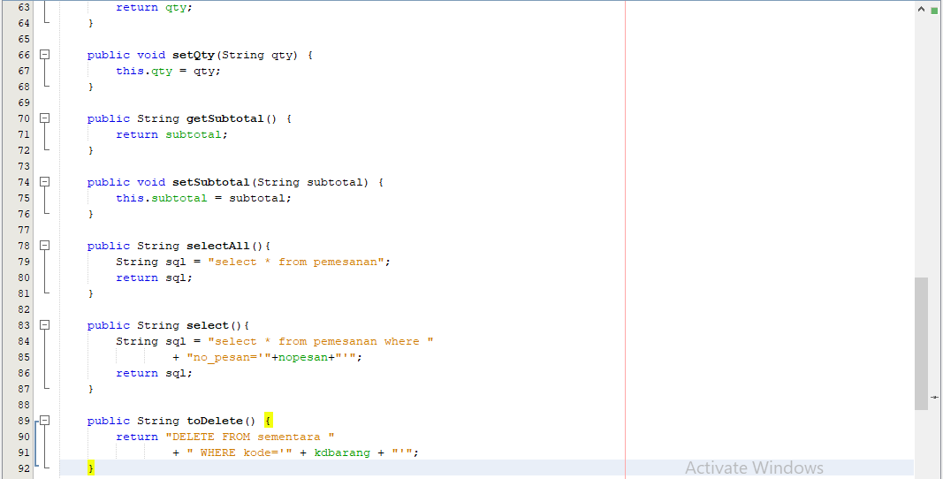

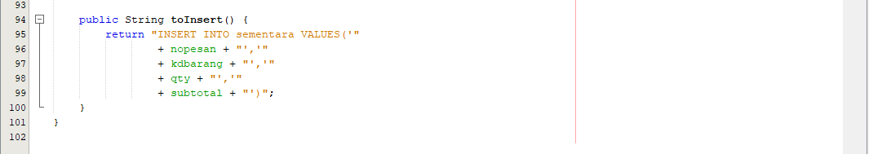

AKUN.JAVA

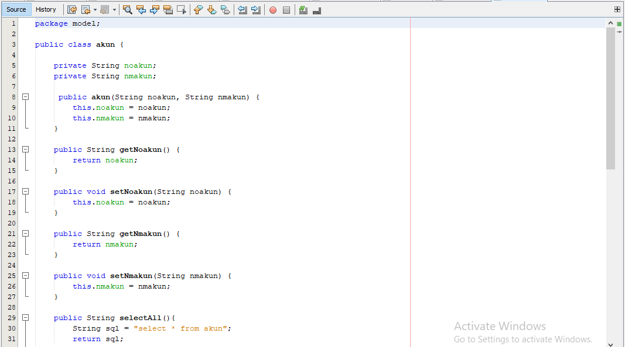

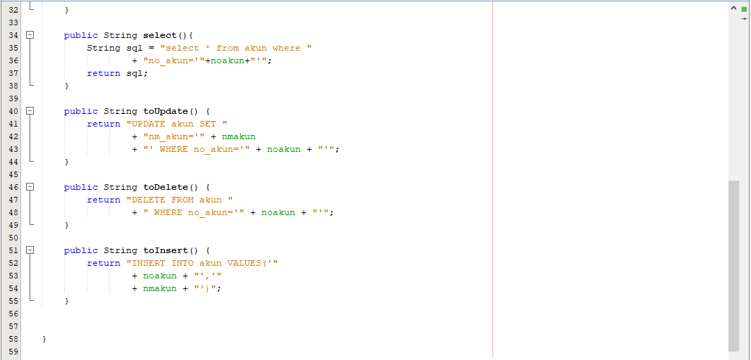

USER.JAVA

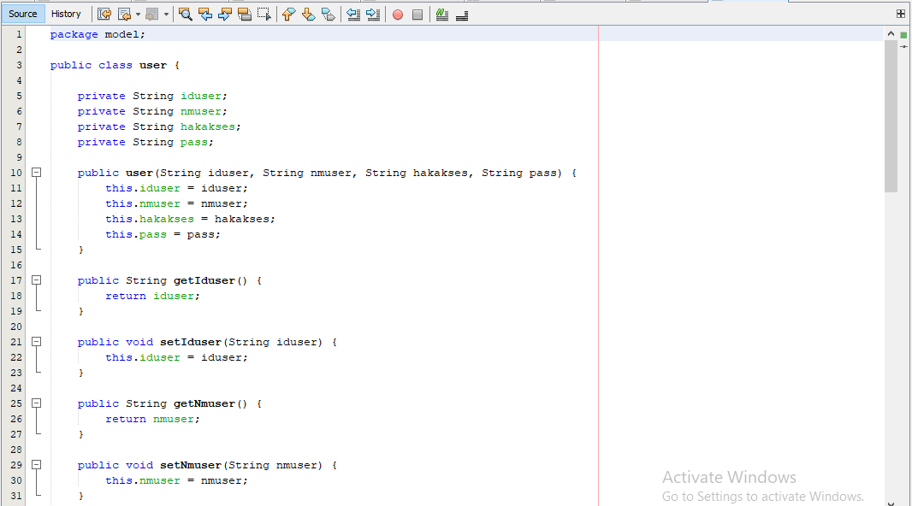

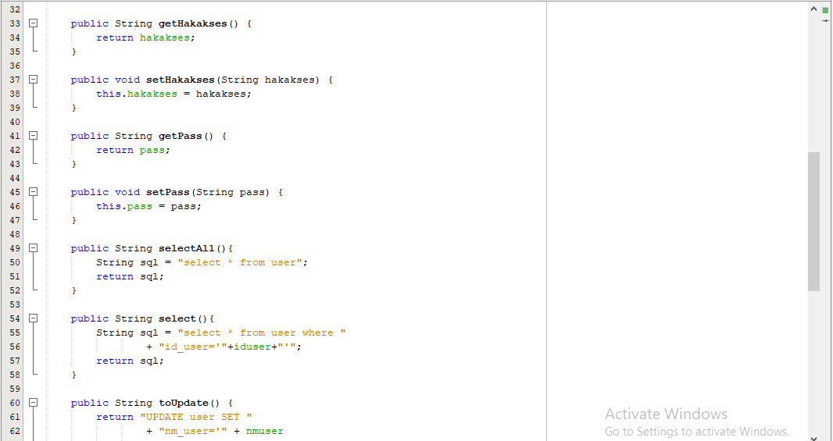

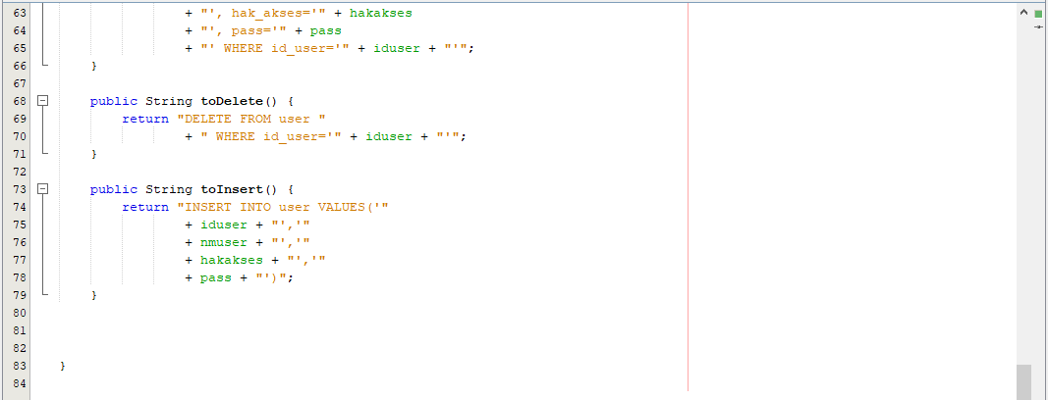

PENJUALAN.JAVA

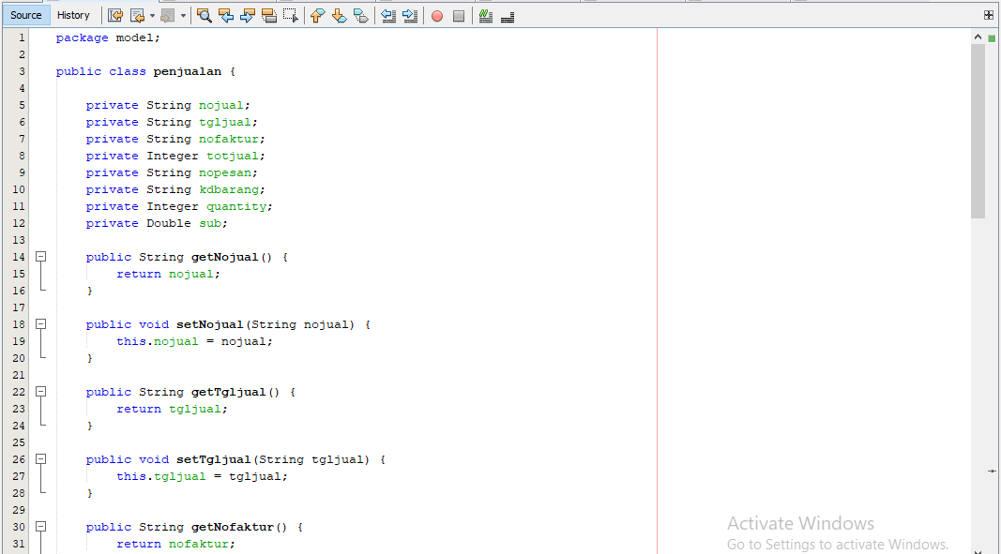

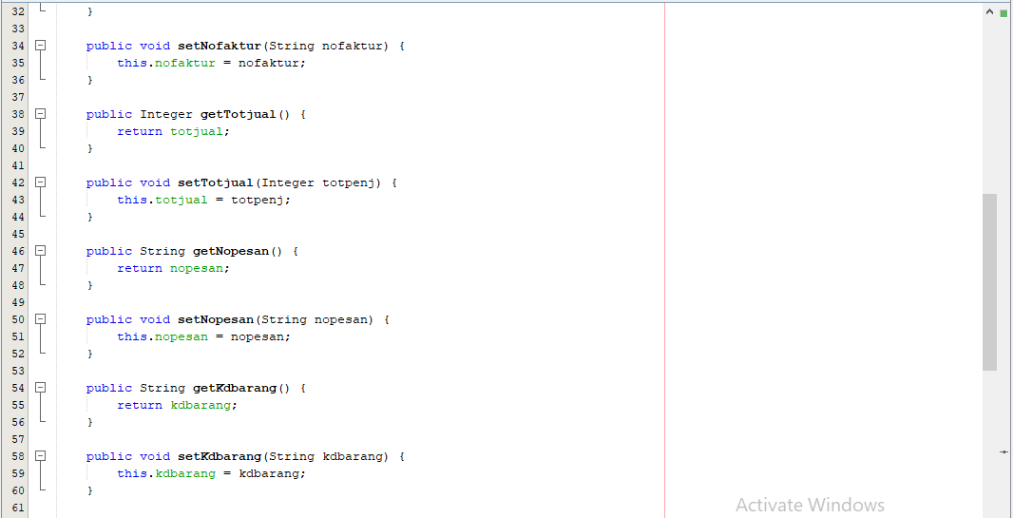

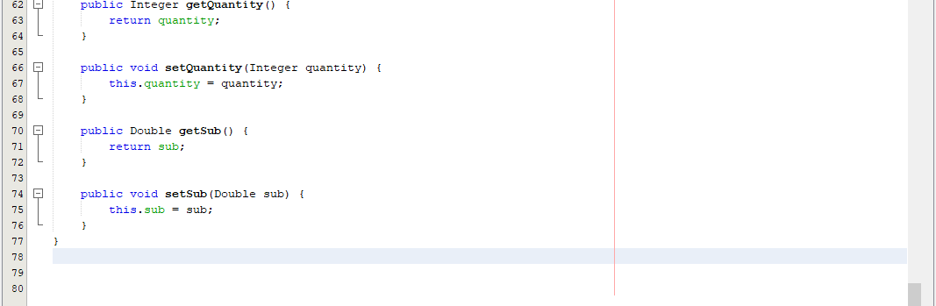

BARANG.JSP

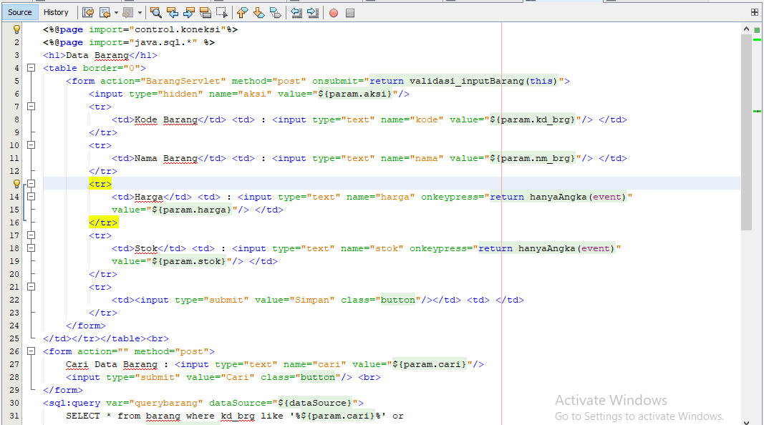

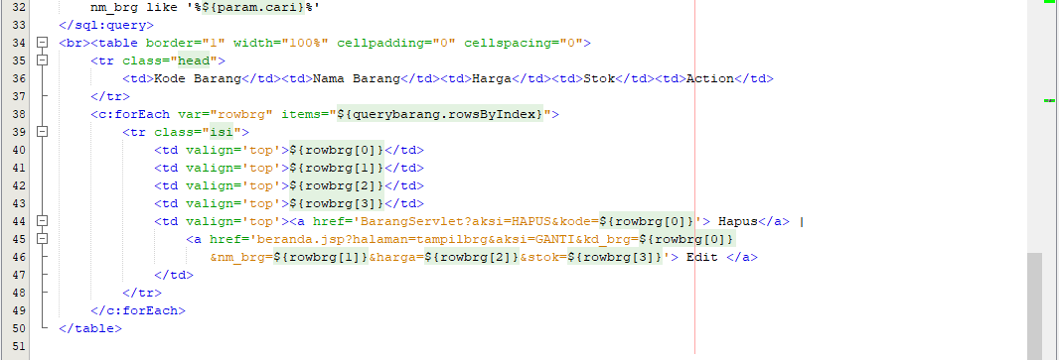

BARANGSERVLET.JAVA

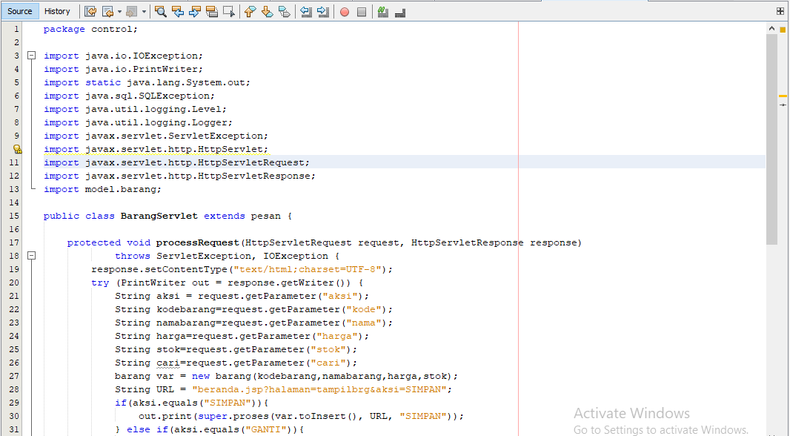

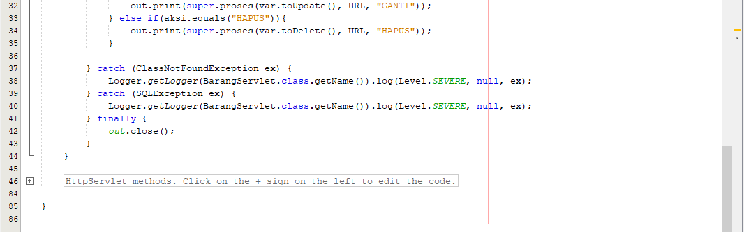

SUPPLIER.JSP

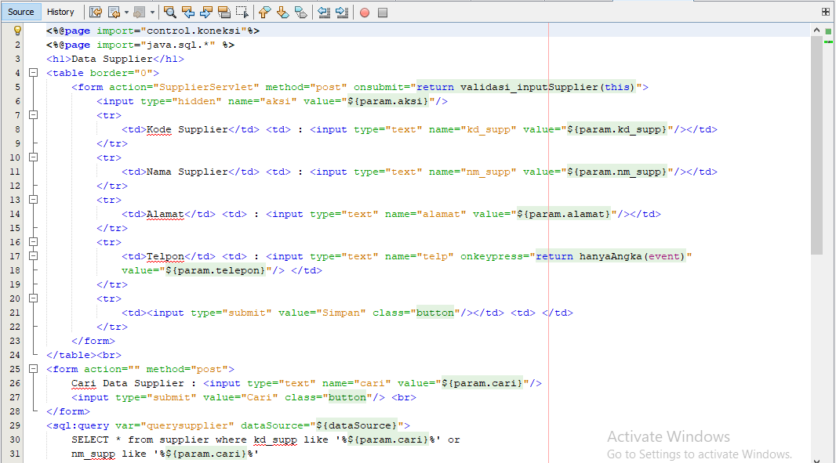

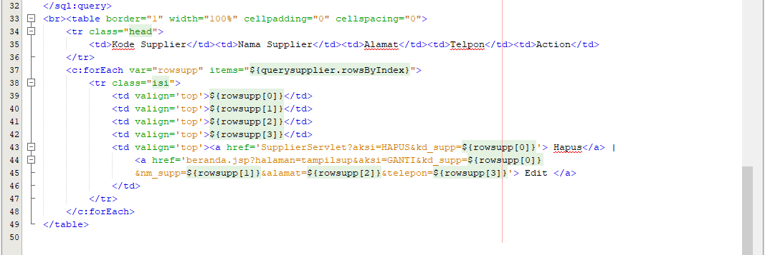

SUPPLIERSERVLET.JAVA

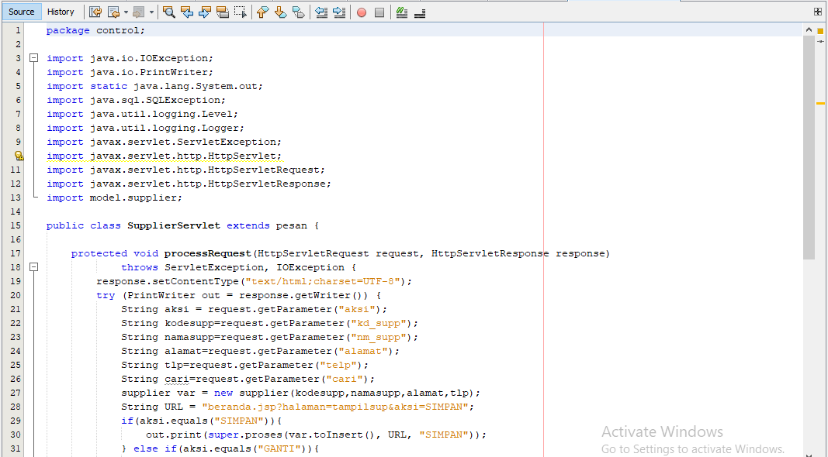

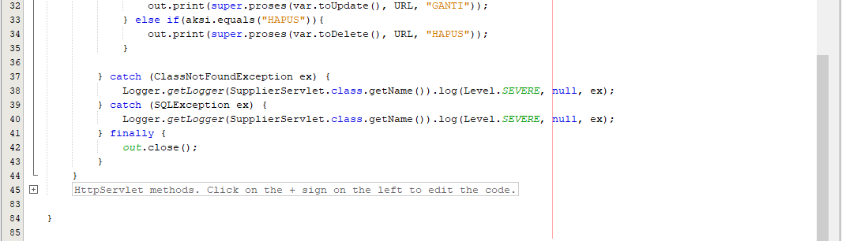

PEMESANAN.JSP

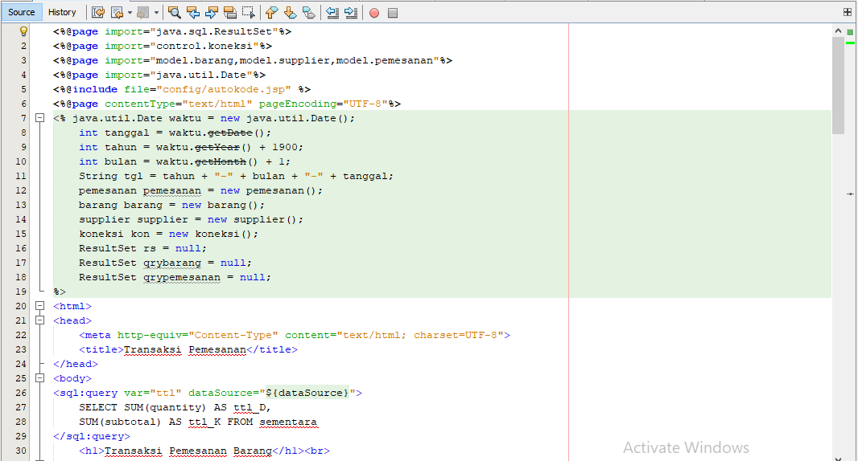

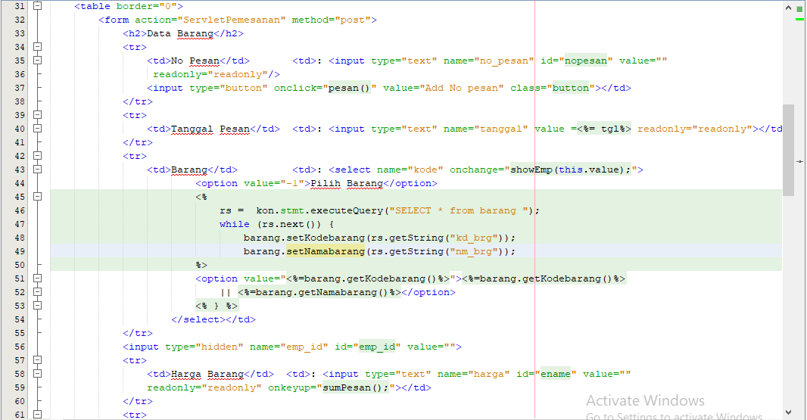

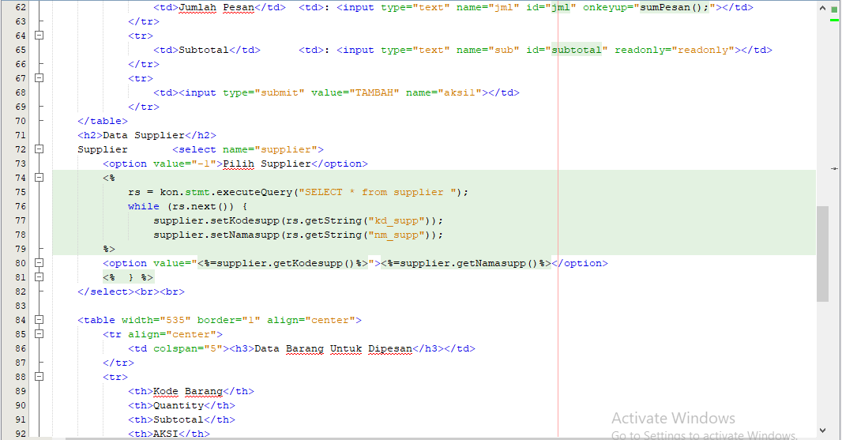

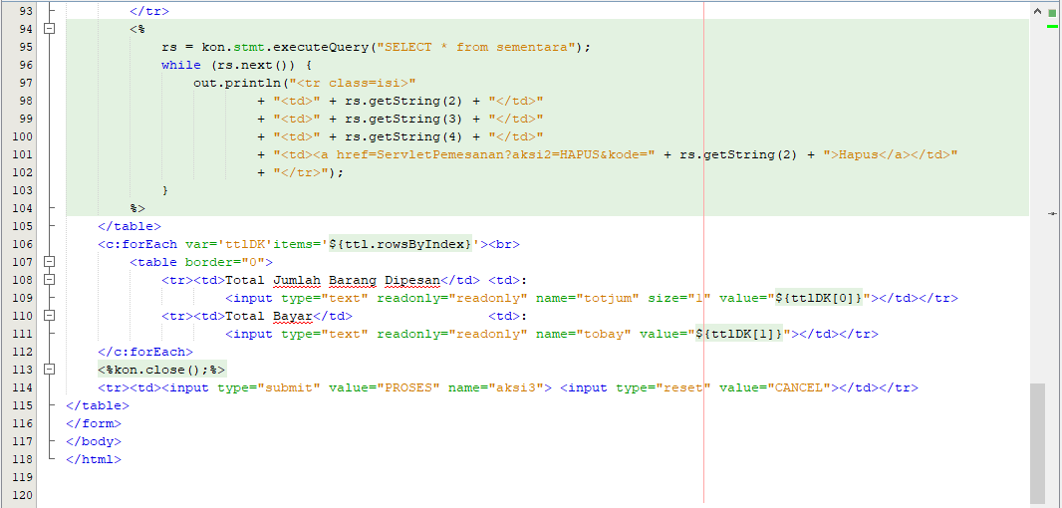

SERVLETPEMESANAN.JAVA

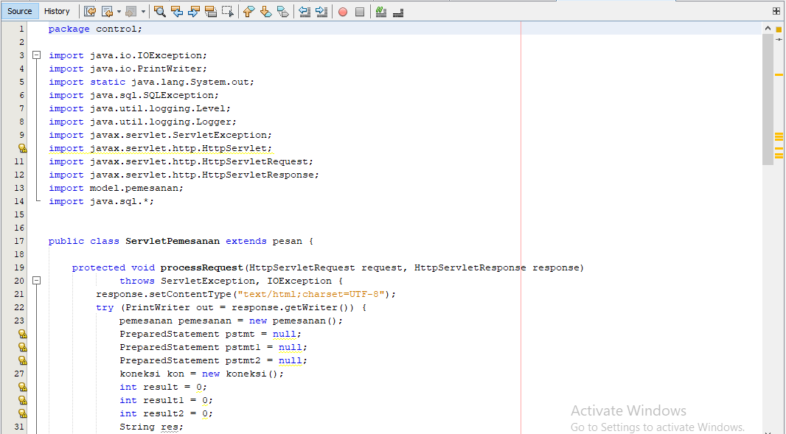

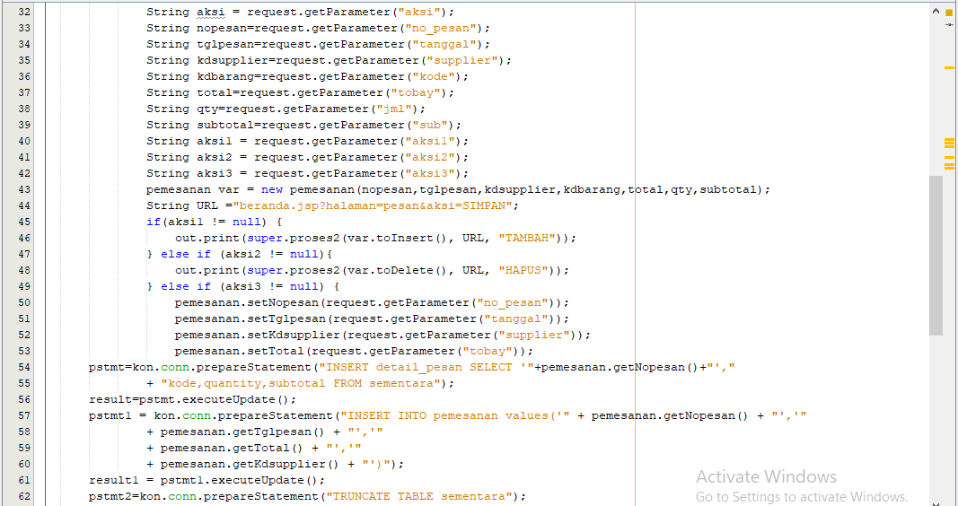

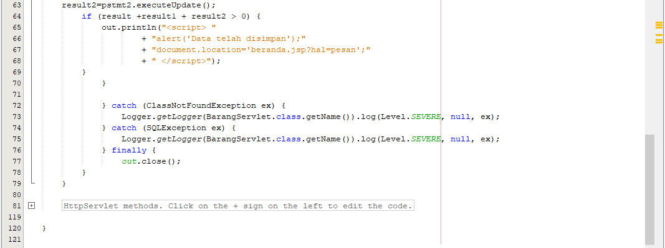

GETBARANG.JSP

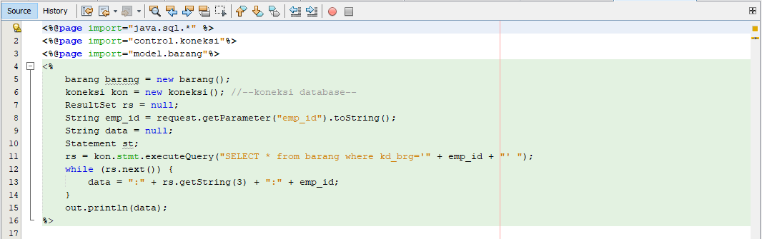

AKUN.JSP

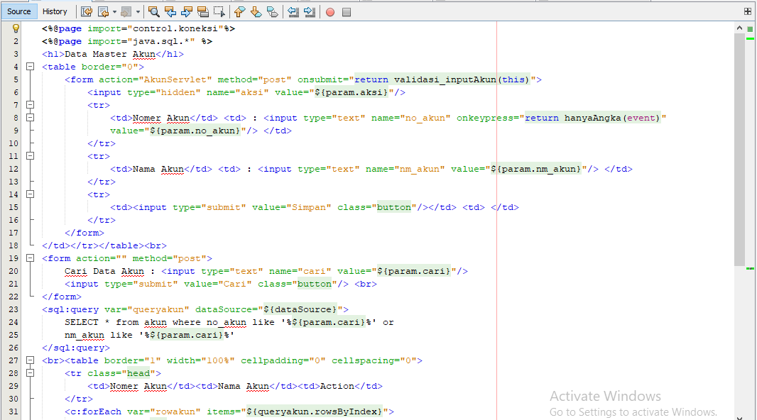

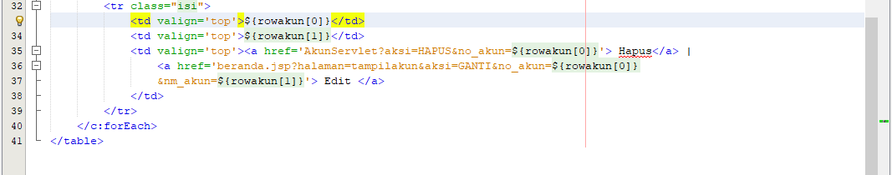

AKUNSERVLET.JAVA

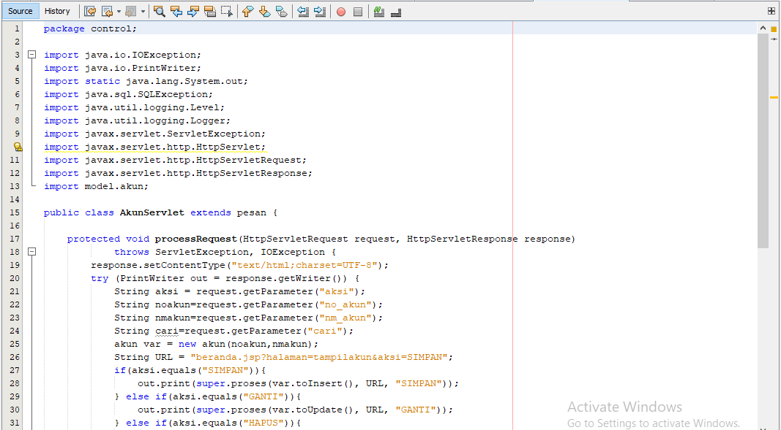

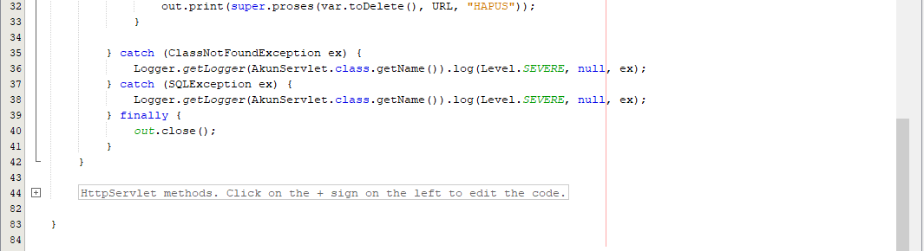

USER.JSP

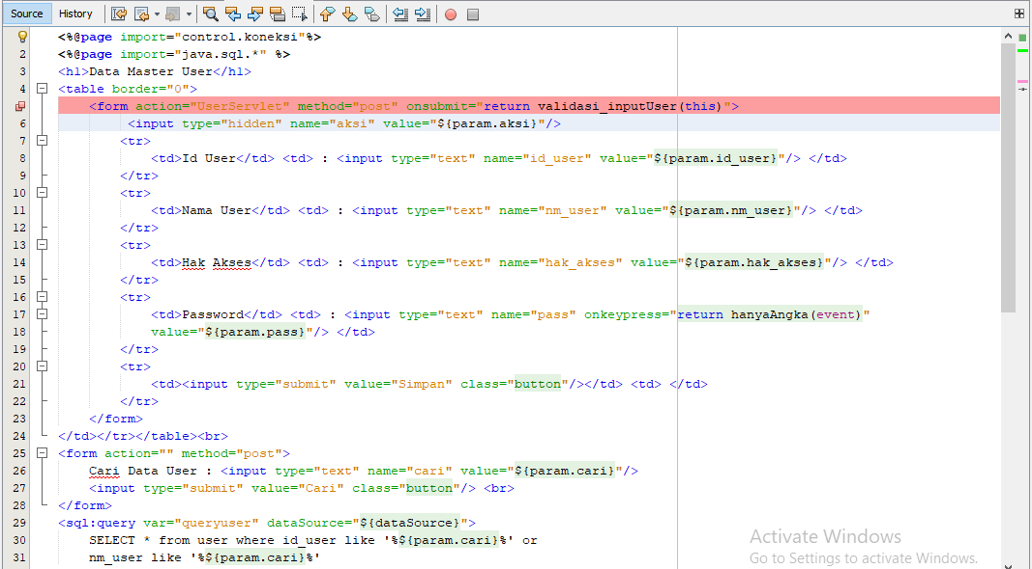

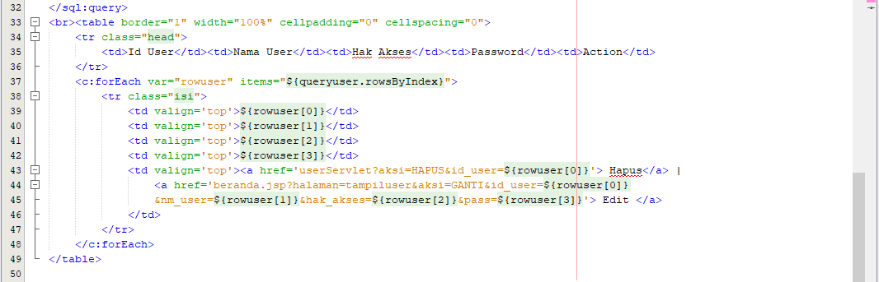

USERSERVLET.JAVA

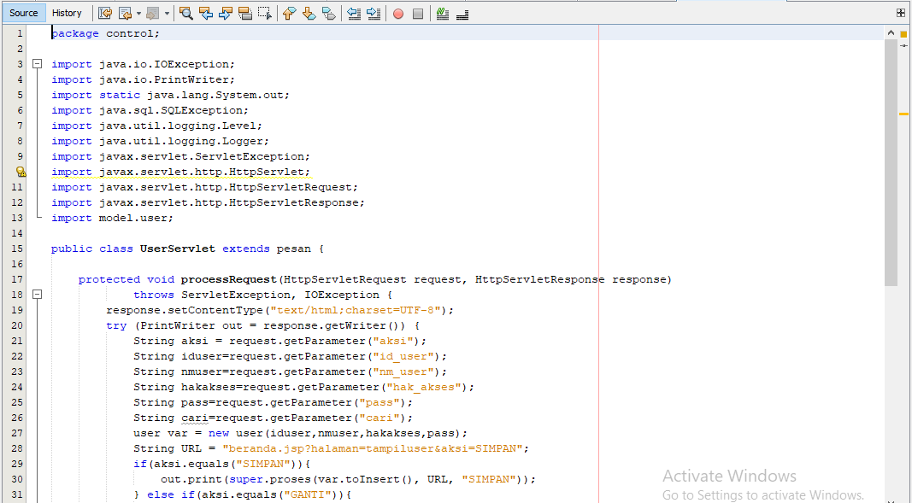

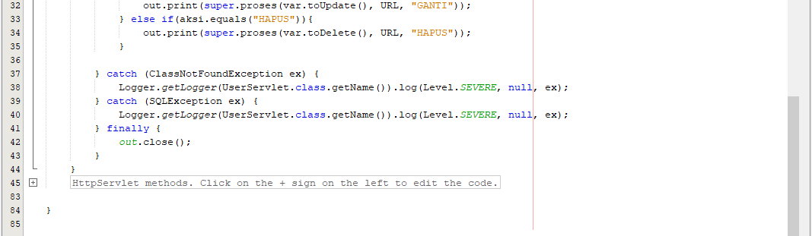

BERANDA.JSP

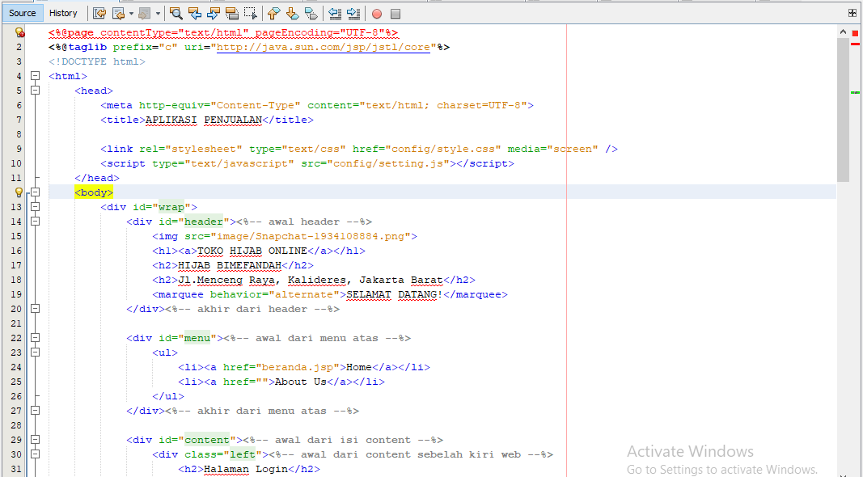

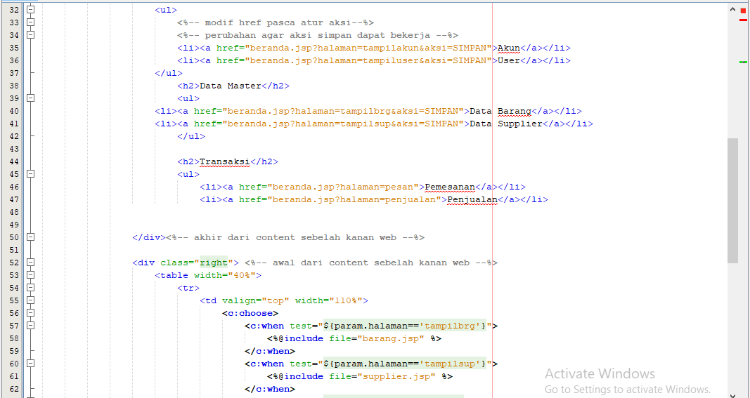

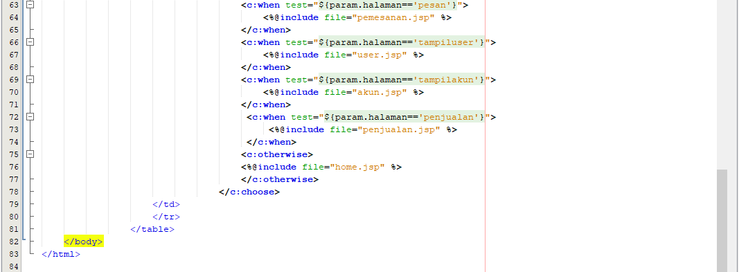

TAMPILAN RUN